PNEUMATIC & HYDRAULIC CO.

Operations Manual

Mobile Refueling System Dispenser Operations

Dispenser Operation

Revision 6

Date Created: 5/27/2025

Table Of Contents

Warranty 8

Safety Statement 9

Introduction 10

Dispenser Setup At New Location 10

Dispenser Startup Procedure 13

Pre-Use Testing 15

Preventive Maintenance 23

Dispenser Shutdown 24

Preparation For Mobilization 27

**P&ID Valve Legend**

Within this manual you will see the following abbreviations representing components in this Hydrogen Mobile Refueler.

|  |  |
| --- | --- |
| ABBREVIATION | DEFINITION |
| MIV | Manual Isolation Valve |
| MVV | Manual Vent Valve |
| DCIV | Digitally Controlled Isolation Valve |
| DCVV | Digitally Controlled Vent Valve |

# Warranty

Seller provides the following limited warranty for all equipment of Seller’s manufacture or assembly for a period of one (1) year from the date of shipment to Buyer: such equipment will materially meet the written specifications stated in the order and will be of good quality and workmanship for the equipment’s ordinary use. This warranty shall not apply to equipment or components not manufactured by Seller. With respect to equipment or components sold but not manufactured by Seller, the warranty obligations of Seller shall in all respects conform and be limited to any warranty actually extended to Seller by its supplier of such equipment or components, and Seller assigns said warranty to Buyer to the fullest extent allowed by law. For any services furnished by Seller (e.g., installation, maintenance), Seller warrants such services will be performed in general conformance with industry standards. All other warranties (for sales, services or otherwise) not expressly stated herein, whether express or implied (including but not limited to the warranty of fitness for specific use or purpose and/or redhibition or latent defects) are hereby waived. Seller’s warranty shall in no event apply to equipment or components which (i) shall have been repaired or altered by any person or entity other than Seller, or (ii) have been subjected to improper maintenance, operation or storage, other than normal usage or service, negligence or fault of any person or entity other than Seller, accident, or damage by any circumstances beyond Seller’s control. As the sole and exclusive remedy for any breach of warranty, at Seller’s sole option, Seller will either (i) repair or replace any non-conforming equipment or component(s) and/or re-perform any non-conforming services, or (ii) accept return of the non-conforming equipment or component(s) and return the purchase price or other compensation for applicable non-conforming services or goods to Buyer, in all cases without any other liability whatsoever, it being agreed that in no event will Buyer be liable for any costs or expenses for labor, transportation, removal, installation or other expenses in connection with the repair of replacement. In no event will Seller be responsible for any consequential, indirect, punitive, economic, or incidental damages which may be suffered by Buyer arising in any way out of the sale or services hereunder, regardless of whether occasioned by breach of warranty, negligence or other fault of Seller, its affiliates, suppliers, vendors, and/or subcontractors of any tier, and/or the employees of the foregoing. Notwithstanding any other provisions herein, in no event will Seller’s liability for warranty exceed 120% of Seller’s price or compensation for non-conforming equipment or services. Buyer releases, defends, and indemnifies Seller, its affiliates, distributors and vendors of any tier and their employees (“Seller Group”) for all liabilities, claims and causes of action for any, and all damages other than Buyer’s liability under the limited warranties hereof, REGARDLESS OF WHETHER CAUSED BY THE NEGLIGENCE, BREACH OF WARRANTY/DUTY, OR OTHER FAULT OF AND MEMBER OF SELLER GROUP. Buyer shall carry insurance of all types and amounts necessary to fully insure Buyer’s defense, indemnity and hold harmless obligations herein to the fullest extent allowed by law, but in no event less than $10 million of Comprehensive General Liability coverage, and all such insurance shall name Seller Group as additional insured, waive subrogation rights and be primary/non-contributary as respects Seller Group (all of such insurance is collectively referred to as “Seller’s Insurance”). Seller represents and guarantees that Seller has recovered all costs of Seller’s Insurance in the negotiated contract price for the sale and any services hereunder. CANCELLATION. Buyer may not terminate or cancel for convenience, or direct suspension of manufacture, except with Seller’s written consent signed by an officer of Seller and then only upon terms that will compensate Seller for the cost incurred as a result of any engineering, fabrication, purchasing, or any other cost relating to such termination, cancellation, or suspension, plus a reasonable amount for profit. ENTIRE AGREEMENT/MISC. These terms and conditions, and the matters set forth on the face of Seller’s offer to sell, constitute the entire agreement between Seller and Buyer. No prior or subsequent understandings, agreements or representations, express or implied, are part of this contract, nor shall any subsequent modification agreement or representation become part of this contract unless expressly agreed to in writing by an authorized representative of the Seller. In the event it becomes necessary for Seller to incur any costs or expenses in the collection of moneys due Seller from Buyer, or to enforce any of its rights or privileges hereunder, Buyer upon demand shall reimburse Seller for all such costs and expenses including but not limited to, reasonable attorney's fees, expert fees and costs of suit. Any typographical or clerical errors made by Seller in any quotation, acknowledgement or publication are subject to correction. This agreement shall be governed by the laws of the State of Louisiana, without giving effect to the choice of conflicts of law provisions thereof, and the parties expressly agree to exclusive jurisdiction and venue in the court of the Parish of Lafayette, Louisiana for any dispute arising hereunder.

Safety Statement

To ensure this quality product is safely and correctly utilized, all instructions within this manual must be read and understood prior to equipment start-up. Be aware of all the safety labels on machinery. If you do not understand any of the safety instructions contact your supervisor or product supplier immediately!

Compliance with safety standards, including federal, state and local codes or regulations is the responsibility of the purchaser(s). A safety study should be made of the products’ application by the purchaser(s). It is the purchaser’s responsibility to provide any additional guards, safety labels or other safety equipment deemed necessary based on this safety study.

The information contained in this safety manual is correct at the time of printing. Due to the continuing development of product lines, changes in specifications are inevitable. The company reserves the right to implement such changes without prior notice.

If you suspect fire hazards, safety hazards, dangers to health or any other job safety concerns, consult your federal, state or local codes.

Inspect equipment for safety labels. Make sure the personnel are aware of and follow safety instructions. Always maintain an orderly environment in the vicinity of Mobile Refueler. Clean up spilled materials or lubricants immediately. All personnel shall be instructed regarding the necessity for continuous care and attention to safety during the operation. They must be trained to identify and immediately report all unsafe conditions or practices relating to Mobile Refueler and its operation. Know your company’s machine specific Lockout / Tagout procedure. Do not perform maintenance until the electrical disconnect has been turned off! Replace all safety devices, guards and guarding prior to equipment start-up.

All electrical installations and wiring shall conform to federal, state and local codes.

Control stations should be so arranged and located that the operation of the affected equipment is visible from them. Control stations should be clearly marked or labeled to indicate the function controlled.

Remotely and automatically controlled products, and products where operator stations are not manned or are beyond voice or visual contact from drive areas, loading areas, transfer points and other potentially hazardous locations on Mobile Refueler path not guarded by location, position or guards shall be furnished with emergency stop buttons, pull cords, limit switches or similar emergency stop devices. The emergency stop devices shall be installed so that they cannot be overridden from other locations.

Only trained, qualified personnel shall be permitted to operate this machine. Training shall include instruction in operation under normal conditions and emergency situations.

It is the responsibility of the purchaser of this unit to train operating personnel in the proper manner of operation. It is furthermore understood that PHC Fluid Power assumes no responsibility for injury, disability, or death resulting from improper operation, removal, or bypassing of any electrical or mechanical safety devices incorporated in the design and manufacturing of this product.

The proper clothing for the job is always to be worn. Several types of protective equipment are available which can help you to avoid injury.

Introduction

This document covers the operation of the dispensing unit of the Mobile Refueling System which is used to fuel vehicles or perform transfers.

The dispenser unit requires a supply of high purity hydrogen gas and 24V electrical power. In the case of the mobile refueling system both are supplied by the gas compression system and the dispenser does not require any input connections beyond following the commissioning procedure for the compression and cooling systems of Mobile Refueling System.

Dispenser Setup At New Location

Each time the Mobile Refueling System is moved to a new location it is recommended that the following actions be taken before using the dispenser.

**Fueling Nozzle Transport Guidance**

WEH recommends that fueling nozzles and hoses be disconnected from the dispenser during transport using the integrated breakaway system. This procedure is intended to prevent potential damage to the nozzles, hoses, and breakaway couplings due to vibration, movement, or mechanical stress during transit. Upon relocation, the fueling system should be reconnected per the manufacturer's published instructions.

<https://www.weh.com/en/downloads/index/index/?file=aHR0cHM6Ly9waW1jb3JlLnByZC53ZWgua29uZWt0aS54eXovRG93bmxvYWRzL09wZXJhdGluZy1JbnN0cnVjdGlvbnMvSHlkcm9nZW4tRnVlbGluZy1Db21wb25lbnRzL3RzYTEtaDItb3BlcmF0aW5nLWluc3RydWN0aW9ucy1lbi5wZGY%3D>

However, in instances where disconnection is not feasible or not preferred, a secondary securing method **may be employed** to immobilize and protect the fueling nozzles and hose assemblies. This method must be designed to prevent movement, reduce strain on the breakaway interface, and allow for unobstructed access to the release/reset mechanism if needed.

**Note:**  
Any decision to leave the nozzle system connected during transport should include a risk assessment and engineering controls that ensure compliance with applicable safety standards. PHC assumes no liability for damage or failure arising from alternative transport methods that deviate from WEH’s published guidance unless those methods are explicitly validated through engineering analysis and field testing.

**Installation of Flame Detector:**

It is recommended that the dispenser flame detector not be installed when the unit is being transported. Upon setup at a new location the flame detector must be mounted and wired.

Figure 1: Flame detector

1. Mount the flame detector on the dispenser using the pre-installed mounting bracket. The detector is attached to the mounting bracket by a single bolt as shown in the figure below. However, do not fully tighten the bolt yet.
2. The flame detector needs to be pointed towards the area where vehicles will be parked during fueling operations. Rotate the flame detector so that it’s direction is aligned with the fueling area. Then tighten the mounting bolt.
3. The flame detector’s aim can also be adjusted up or down as required. To adjust the vertical aim of the flame detector, loosen the bolt in the hinge joint in the mounting bracket and adjust the aim of the detector. Then retighten the hinge joint bolt.
4. In order to prepare to make the electrical connections for the flame detector unscrew the cap from the back off the detector housing exposing the terminal block.
5. Remove the weatherproof cable fitting from the bottom side of the detector housing and slide the fitting over the end of the cable.
6. Feed the end of the cable through the cable entry port so that the individual wires can reach the terminal block.
7. The overall system is configured for the flame detector to be installed in a Source 3-wire configuration. First confirm that there is a jumper wire already installed between terminals 3 and 11. If there is not, install a jumper wire between terminals 3 and 11.
8. Next, Connect V+ to terminal 1, GND to terminal 2 and the data wire to terminal 4.
9. Reinstall the cap on the back of the detector housing.
10. Tighten the weather proof cable connector on the bottom of the detector housing.

Additional details regarding mounting and wiring of the flame detector can be found in the manufacturer's manual.

[https://www.fgdetection.com/_files/ugd/635c06_8af61a534e4b4782bf4d9ac11e44ddae.pdf](https://www.fg-detection.com/_files/ugd/635c06_8af61a534e4b4782bf4d9ac11e44ddae.pdf)

**Adjust manual valves to normal operating position:**

Prior to operating the dispenser, it must be ensured that all manually operated valves are in the correct open or closed positions. During normal operations of the dispenser unit the manual valves will remain in the conditions shown below in Table 1.

Inside the dispenser cabinet there is a label on or near each valve corresponding to the identifier in the first column of the table below. For further clarification when identifying the various valves, the P&ID drawing for the dispenser system can be consulted. The P&ID is provided below in Figure 2.

|  |  |
| --- | --- |
| Manual Valve Identifier | Condition |
| MIV-600-1 | Open |
| MIV-600-2 | Open |
| MIV-600-3 | Open |
| MIV-600-4 | Open |
| MVV-600-1 | Closed |
| MVV-600-2 | Closed |
| MVV-600-3 | Closed |
| MVV-600-4 | Closed |
| MVV-600-5 | Closed |
| MVV-600-6 | Closed |
| MVV-600-7 | Closed |

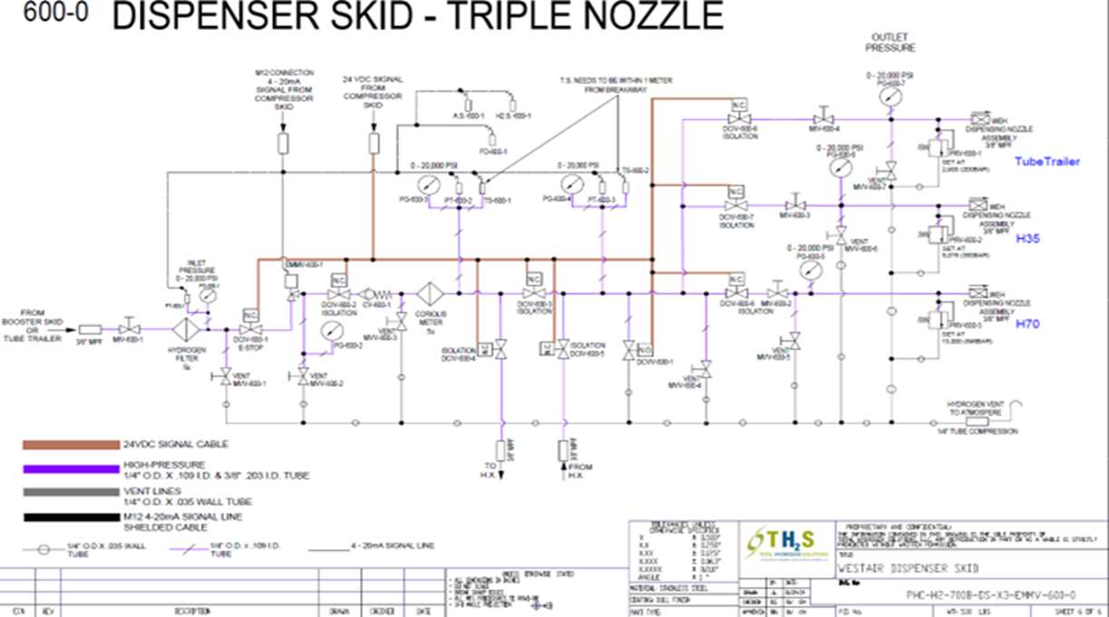Table 1: Manual Valve Conditions during Normal Operations

Figure 2: Dispenser P&ID

# Dispenser Startup Procedure

**Startup Process:**

The dispenser is equipped with a red emergency stop(E-Stop) button on the exterior of the unit that can be pressed to disable the unit if a hazardous situation occurs. The dispenser can’t be operated when the E-Stop is engaged.

Figure 3: Emergency Stop Button

To ensure the E-Stop button is not engaged and will allow the dispenser to operate do the following.

1. Press the button. If it depresses and latches the E-stop was not engaged but now is engaged and if it does not depress the E-stop was already in the engaged position.
2. To disengage the E-stop apply slight pressure while rotating the button. When rotated the button will unlatch and return to the disengaged position.

The dispenser is now ready to be powered up.

1. If it is not already, open the left access door of the Mobile Refueling Unit.
2. To power up the dispenser module simply rotate the red and yellow switch to the ON position.

Figure 4: Dispenser Reset Button and Power Switch

Once the PLC boots, the HMI screen mounted in the left access door will be on and showing the dispenser home screen as seen below in Figure 5.

Figure 5: HMI Home Screen

# Pre-Use Testing

**Hydrogen Sensor Test:**

The Dispenser is equipped with a Hydrogen gas sensor inside the dispenser cabinet to detect leaks to alert to dangerous conditions inside the dispenser cabinet. The hydrogen sensor is mounted on the rear wall of the dispenser system as shown in Figure 6.

Figure 6: Hydrogen Detector

The current level of hydrogen detected by the sensor is shown on the detector LCD screen and is also presented on the dispenser HMI screen on the Maintenance screen. The output from the detector is continuously displayed and represents the amount of hydrogen sensed in parts per million(ppm). Under normal conditions when no hydrogen is detected the reading will be near zero and can even give slightly negative readings. The hydrogen detector is set to raise an alert when a value of 500 ppm or more is reached. The sensor becomes saturated at 2000 ppm and will not show values greater than 2000.

To perform a function test of the hydrogen sensor perform the following steps:

1. With a small sample bottle or other source of hydrogen, release a small amount of gas directly under the black sensor housing of the hydrogen detector.
2. Observe that the hydrogen detector senses and displays an elevated value.
3. After the detector value has peaked, observe that the detector output returns to near zero over a few minutes.
4. If the detector returns to near zero levels the test is concluded however if it does not return to normal levels or displays and error message, consult the detector manual at the link below.

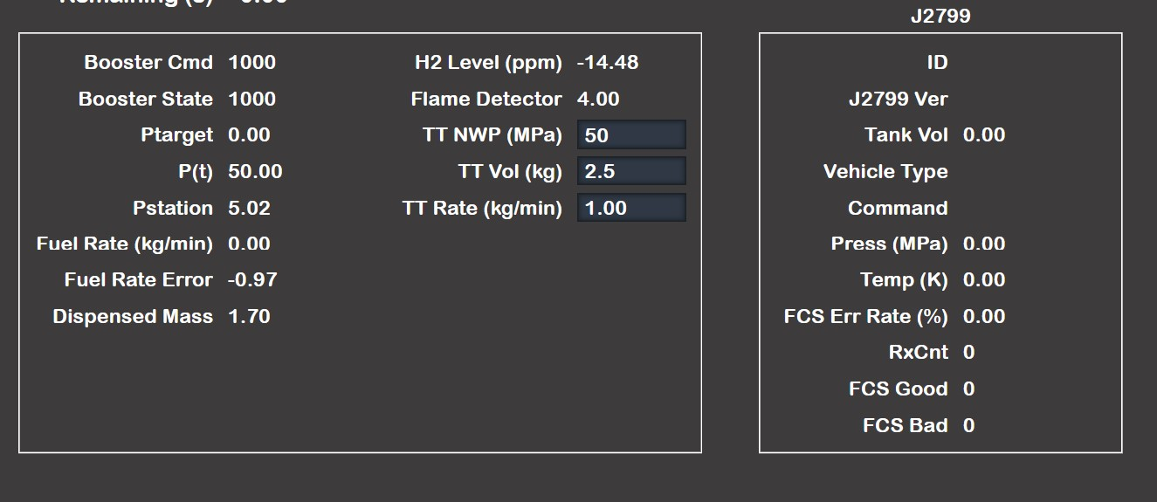

Figure 7: Hydrogen detector HMI output

Detailed information concerning the hydrogen sensor can be found in the product manual.

[Instructions for use Dräger Polytron 5000 Series - Edition 03](https://www.draeger.com/Content/Documents/Products/polytron-5000-series-ifu-9033825-deen.pdf)

**Flame Detector Test:**

The flame detector uses infrared sensors to detect the presence of burning flames. It is recommended that the Flame Simulator Kit (TXP-FDE IR3-H2, SS) from the flame detector manufacturer be used to confirm the functionality of the flame detector.

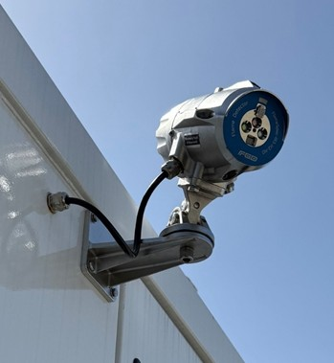

Figure 8: Flame Simulator

The flame detector outputs a current signal of 4 to 20 mA. The current output from the detector is displayed on the Maintenance screen of the HMI. When no flame is detected the output from the detector is 4 mA. When a flame is detected the output is between 16 and 20 mA and an alert message will appear.



Figure 9: Flame Detector HMI Output

To test that the Flame Detector is functioning properly using the flame simulator perform the following steps.

1. Confirm on the HMI screen that the Flame Detector output is 4 or very close to 4 mA indicating that no flames are currently detected.
2. Using the flame simulator, aim it towards the flame detector and activate the unit.
3. Observe if the value being received from the flame detector increases to a value between 16 and 20 mA. If so the simulated flame has been detected.
4. Turn off the flame simulator and observe if the output value returns to near 4 mA. If it does the flame detector is functioning properly.

**E-Stop FunctionTest:**

The emergency stop system should be tested when commissioning a system. The E-stop system can be activated using the mechanical button mounted on the dispenser or by touching the E-Stop button on the HMI screen. Both methods can be quickly tested.

To test the function of the E-stop system perform the following:

1. With the system on, simply press the mechanical button on the dispenser. The HMI screen will display a message that the Emergency Stop has been activated. All other functions are disabled while the Emergency Stop is activated.
2. To return to normal operations when the mechanical button has been used to initiate an emergency stop, the mechanical button must first be reset by applying light force on the button and rotating it until the button extends outward.
3. Next the system reset button must be pressed. The system reset button is located on the gauge panel inside the left rear door of the dispenser unit. The reset button is a push button near the power switch.
4. Once the reset button has been pressed, the PLC will reboot and the HMI will return to its home screen.

Figure 10: Dispenser Reset Button & Power Switch

To reset the E-stop system when the mechanical button has been depressed, the button must be rotated while applying force to allow it to reset. Now the system Reset button must be pressed. The system Reset button is located in the lower lefthand corner of the manual gauge panel inside the dispenser behind HMI screen. Once the Reset button is pressed, the PLC will reboot and the HMI should return to the home screen.

For thoroughness, next test that the E-stop can be activated from the HMI screen. From Fuelling screen, touch the E-Stop button. The message should appear indicating that the emergency stop has been activated. Reset the system using the button on the gauge panel.

Figure 11: Maintenance Screen

**Pressure Test:**

The dispenser should be pressure tested to check the system for any hydrogen leaks prior to being put in service once it arrives at a new location.

1. On the HMI navigate to the Maintenance screen.
2. Near the schematic of the Dispenser piping circuit on the HMI switch the button labeled Manual Mode to the on position. Once in Manual Mode the valves shown as either open(green) or closed(red) on the schematic can be operated by simply touching the valves on the HMI screen.
3. Next, find the box next to the valve controls that has data labels FC%, FC Val and FB%. In manual mode the FC% allows for the user to set what percentage of fully open the flow control valve is set. The percentage can be adjusted using the + or – buttons or by clicking on the value and an entry pad will appear. Now set the FC% to 20. The FB% should begin to change until the set position is reached. The FC% is the set point for the flow control valve and the FB% is the current position as indicated by feedback from the valve. The FC Val is the actual control signal in volts being sent to the flow control valve.
4. Once the Flow Control Valve has been opened to 20%, proceed to opening the Digital Control Valves DCIV02, 03, 04, 05, 06, 07 and 08 by touching the respective valves on the HMI screen. Afterwards, all valves will be open(green) except for the vent valve DCVV01. The system is now ready for pressure testing.

Figure 11: Manual Mode Switch, Valve Control and Flow Control Valve Input

1. A screenshot of a vehicle dashboard

   AI-generated content may be incorrect.Next inside the box labeled VEHICLE, touch the blue Tube Trailer button.

Figure 12: Vehicle Type Selector Buttons

1. Below the box labeled VEHICLE, there are two boxes containing data fields. Find the data field named TT NWP (MPa). This field allows for input when the grey box is touched.

Figure 13: Tube Trailer Working Pressing Input Box



1. Enter the initial test pressure for the dispenser as 73 MPa (730 bar). After the pressure is locked in and settles it will decrease to a lower value but should be greater than 65 MPa (650 bar).
2. Next, toggle the switch labeled Pressure Pulse. This will pressurize the entire dispenser system.
3. Close valve DCIV02. The pressure should stabilize at a value greater than 65 MPa. The goal is to let the system stabilize at a pressure above 65 MPa to allow for the beginning of the 1 hour pressure hold.
4. When the system has stabilized at a pressure above 65 MPa, record the starting pressure and the time. To pass the pressure test, the system should lose no more than 2% of the starting pressure over a 60 minute holding period. For example, if the starting pressure after stabilization is 70 MPa the pressure in the dispenser system should be 68.6 MPa or greater at the end of the 60 minute period. At the conclusion of the test record the final pressure and time. If a significant leak is detected the test can be stopped prior to the end of the 60 minute hold time.

If the system does not achieve the 2% loss rate or a significant leak is detected it is recommended to attempt to determine the part of the system which is leaking. The P&ID drawing of the dispenser system can be a useful reference when attempting to narrow down the location of the leaking component or connection.

1. First repressurized the dispenser system to approximately 73 MPa(730 bar) and close DCIV02.
2. Now begin to isolate sections of the system. For instance, close DCIV03 and DCIV05 and watch both the Dispenser Inlet and HX Outlet pressures.
3. If one shows decreasing pressure then it will be known if the leak is before or after the heat exchanger.
4. Then subsequent valves can be closed to isolate the leak further. It may be useful to also operate some of the manual isolation valves and use the manual pressure gauges inside the dispenser cabinet to isolate leaking components.
5. Once a leak is narrowed down to a section of the system, then a handheld hydrogen sensor can be used to attempt to identify a specific connection or component as the source of the leak.
6. Before attempting to tighten any fittings or replace any components to fix a leak, the dispenser system should be depressurized. With DCIV02 and vent valve DCVV01 remaining closed, open all control valves DCIV03 through DCIV08.
7. Next open vent valve CDVV01. This will vent all pressure downstream from DCIV02. To ensure no pressure can be supplied during work on the system close manual isolation valve MIV-600-1. This will isolate the dispenser from the booster system.
8. Finally open DCIV02 to vent any hydrogen trapped between MIV-600-1 and DCIV02.
9. Tighten or remake any suspected leaking connection.
10. Close vent valve DCVV01 and reopen manual valve MIV-600-1.
11. The system can now be repressurized(going back to Step 1) to assess if the leak has been fixed.
12. If the leak has been resolved then the pressure test procedure presented previously can be followed to conduct the 1 hour pressure hold test.

**Vehicle Fueling Test:**

It is recommended that at least one fueling test for each service class(eg. H70, H35, etc.) be conducted prior to putting a dispenser into service to test the functionality of the entire system.

1. Connect the appropriate fueling nozzle for the desired service class to the vehicle or tanker.
2. From the main menu of the HMI select Ready to Dispense.

Figure 14: Home Screen

1. On the following screen select the service class to match the nozzle chosen and vehicle.
2. Select Continue.

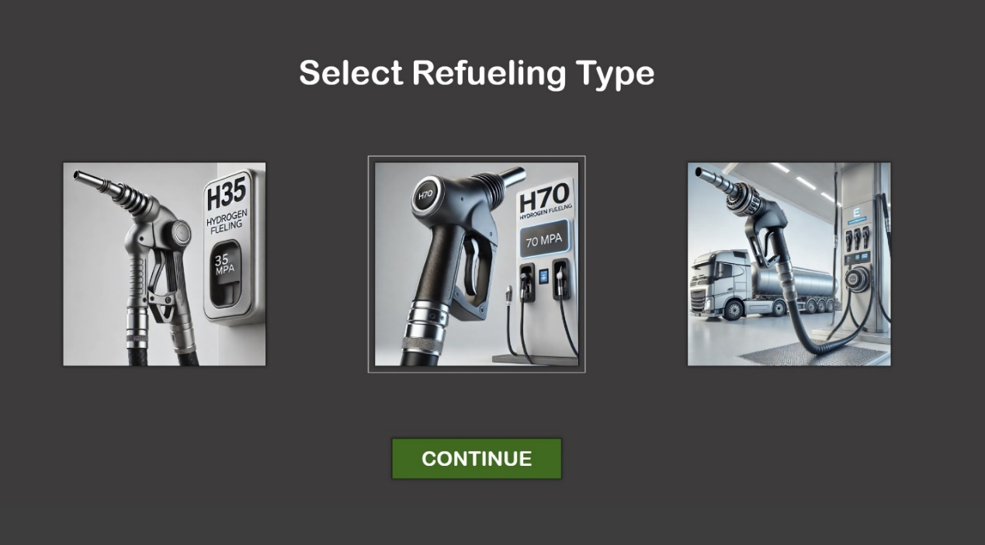

Figure 15: Service Type Selection Screen

1. On the following screen select Start Refueling.

Figure 16: H70 Refueling Screen

1. The fueling process will now begin and should continue automatically until the vehicle is full.
2. If the fueling is completed successfully, then the other services classes can be tested if other vehicles or tanks are available.
3. If the fueling process was halted due to a leak or hydrogen sensor alarm. The leak should be addressed by isolating sections of the dispenser as was detailed Pressure Test procedure.

Preventive Maintenance

The dispenser relies on a number of sensors, filters and pressure relief equipment for safe, reliable operation.

These include the following items:

* Pressure Transducers
* Temperature Sensors
* Coriolis Mass Flow Meter
* Flame Detector
* Hydrogen Detector
* Replaceable Gas Filter
* Mechanical Pressure Relief Devices

A documented periodic maintenance plan should be established for the dispenser system. All sensors, meters, transducers and pressure relief devices require periodic calibration. Consult the certification and calibration documentation packet received with the unit to determine the recommended calibration or replacement interval for each device.

Dispenser Shutdown

**Short Term or Overnight Shutdown:**

To shut down the dispenser perform the following steps:

1. From the home screen on the HMI, select settings.

Figure 17: Home Screen

1. On the settings screen toggle the shutdown switch.

Figure 18: Settings Screen

1. Once the HMI screen has turned off, the power switch inside the left rear door of the dispenser cabinet can be switched to the OFF position.

Figure 19: Dispenser Reset Button and Power Switch

**Extended Shutdown:**

If the dispenser is to be shut down for an extended period, the following process should be followed.

1. Inside the dispenser cabinet, close manual valve MIV-600-1. This will shut off the supply of hydrogen from the storage tanks/booster system.
2. From the HMI home screen select Maintenance.
3. On the Maintenance screen toggle the Manual Mode switch.
4. Next set the FC% value to 20.
5. Using the HMI screen opens the Digital Control Valves DCIV02, 03, 04, 05, 06, 07 and 08.
6. Now open vent valve, DCVV01. This will vent the remaining hydrogen in dispenser.

Figure 20: Manual Mode Switch, Valve Control and Flow Control Valve Input

1. After system pressure stabilizes, close DCVV01.
2. Return to the Home screen by pressing the house icon in the upper right-hand corner of the Maintenance screen.

Figure 21: Maintenance Screen

1. On the Home screen select the Settings button.
2. Under System select Shutdown.
3. Once the HMI screen has gone dark, the unit can be powered off using the power switch inside the left rear door of the dispenser.

Preparation For Mobilization

If the Mobile Refueling System is to be moved to a new location the following tasks should be performed prior to preparing the dispenser for mobilization.

**Removal of Flame Detector:**

1. Remove the cap on the back of the flame detector housing.
2. Loosen the weatherproof cable connector on the bottom side of the detector housing.
3. On the terminal on the back of the detector, remove the V+ wire from terminal 1, the GND wire from terminal 2 and the data wire from terminal 4. The jumper wire between terminals 3 and 11 can be left in place.
4. The wires/cable can now be gently pulled through the port where the cable enters the detector body at the bottom of the housing.
5. Replace the cap on the back of the flame detector.
6. While making sure to secure the flame detector from falling, remove the bolt on the underside of the mounting that supports the detector.
7. Place the flame detector in a box or other container and stow it inside the dispenser for travel.

Figure 22: Flame detector